GROUP MEMBERS:
P19-1673---Wahaj Tahir

P19-1672----Ahmed Sattar

P19-1652---- Hifza Majeed

Subject:
Software Requirement Engineering

Project Name:
Bus reservation system (SRS)

1. Introduction
1.1 Purpose:
The purpose of this system is to give the description about the bus reservation system and also tells about the system working that what will this bus reservation system do and also give the facility to customers. It will explain the features of system. It will also tell us that how this system will interact in different circumstances. This is all about the purpose of the software.
1.2 Document conventions:
It will take information step by step from customers and It will show the confirm ticket after giving all information and confirmation of the payment with a green confirmation color.
If a red dialogue box is opening before ticket booking it means that you are entering wrong information. You will be modified after confirm booking your ticket.
1.3 Project scope:
This software will reserve online ticket of the customers and customers can also check when will this bus will leave and when will arrive so that It will provide a complete information and it will reserve ticket as well as person can cancel his ticket if his mind changes. This will reduce the paper work and burden of the labor and have an online information of booked tickets.

1.4 References:
This SRS will refer to the same as online airline ticket reservation system, online hotel booking and also online library management system.

2. Overall description:

2.1 Product perspective:

The system we are using depends on physically collecting tickets from passengers, if passengers are more so it will be difficult in checking tickets, it will give the efficient way of collecting tickets and also payment will be collected online ,it will also saves time. Also passenger can book ticket two or three days before going he/she does not need to come physically and buy tickets.
2.2 User classes and characteristic:
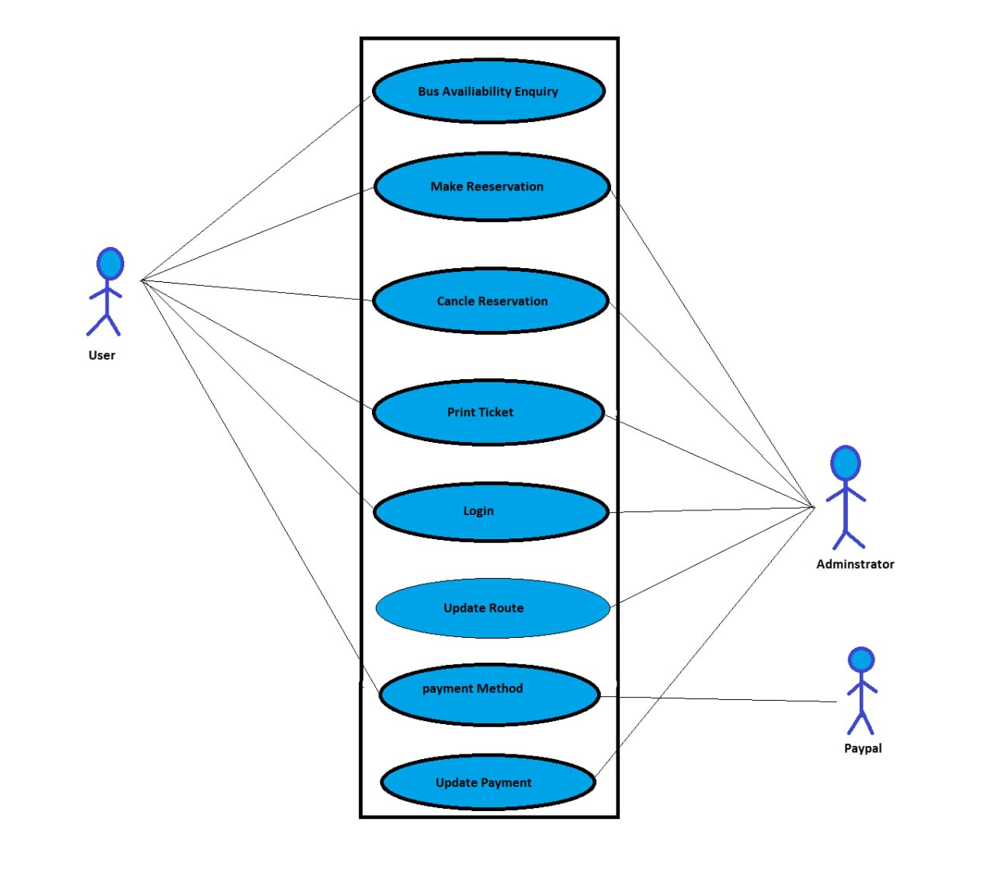

Operating environment:
This software will operate online, under the application of the travelling company and book tickets under the specified software that is permitted by the company.
No other software or any other app will use to confirm tickets for this company.
It will operate and control by the administration.
2.4 Design and implementation constraint:
The system shall use the current corporate standard Oracle database engine.

2.5 Assumption and dependencies:
- This system will be avaiable when the service of the buses will be available.it all depend on the availability of the buses.
- Customer must have unique id for booking
- You cannot cancel your ticket before one hour to departure.
- You should be there before half an to departure.
- You can book your ticket before week to go and Once you book your ticket and payment its confirm then your tickets will not be cancel in any case

- System features:

3.1 booking ticket:
Passenger can book his ticket before one week to go and its ticket will be confirm when its payment will be clear.
3.2 Cancel ticket:
A person can also cancel his ticket only when it’s not get paid once you paid for ticket then you would not be able to cancel.
3.3 Check time&book tickets:
You can check departure and arrival time of the bus online and you can also check how much seats are remaining in the bus.

3.4 Print ticket:
After all successful steps, passenger can print his ticket.
- Data requirements:
- The information of about bus tracking system have different function and data
- Logical data models:
- the user and the system are directly connected to each other.
The best way to explain by Entity relationship model (ER) and UML Class diagram.

4.2 Data dictionary:
Data dictionary is composition of bus reservation system and also the meaning of data type length, string, name, address, make up a structure we make a separate Data Dictionary model to clarify the data type.

5. External Interface Requirements:

5.1 User Interfaces:

In any software interface plays a very important role cause it is an only thing a user will use to perform his/her specific task through it,So it is important to create attractive interface keeping in mind of 10 rules of designing.

5.2 Software Interface:

The bus reservation system software is an app based, web based application software, the components we need to build up this software are database system which stores the user credentials . This software will be coded in python language and web based will be also coded in python language the reason we are using python is because it is easy to use and have much advance libraries in it. Purpose of building a good software interface is to make more likely that people easily attract with friendly interface and it makes easy for them to use rather they get frustrated, While making interface we will keep in mind the customer age, use of decide animation. The flow of the data would be symmetric,The user will gonna have a interface like to book a ride,check schedules,departure and arrival time etc and the customer can directly communicate with employee rest are mention in DFD diagram. As we know that time is a key for success we will make this software efficient and supper effective so we can save the time of the user.

5.3 Hardware Interfaces:

To make a stable and attractive interface we need to run this software on operating system which as minimum specification Core i3 64 bit operating system with at least 4gb of ram and at least a low range of NVIDIA graphic card,the reason we need graphic card is to support a good quality GUI which will enhance the appearance of the interface.

5.4 Communication Interface:

Before login into app the software ask for user credentials like Name,Phone Number or Email,Password and that email or phone number will use to alert about updates or important messages like you have booked the ride successfully, your ride is cancel etc alert messages will be send to them via email or SMS, Same for the customer if he/she want to ask he/she can communicate by selecting Message icon.

6. Quality Attributes:

6.1 Usability:

If we make the software interface super effective and easy to use by keeping in mind of 10 rules for GUI design than definitely the usability of this system will increase and more likely people will like to interact with software.

6.2 Performance:

In (section 5.3) we use this kind of systems than definitely the performance would be stable and use of more server will help the system run smoothly even it is overload. In short it will help overcome the issue of server down.

6.3 Security:

Customer credential security our first and very important task the system should have a capability to hide the user info like passwords, credit card pin etc. This is our most important task to keep the user privacy and do not share it with others.

6.4 Safety:

In (Section 6.3) keeping care of user privacy is our first and important task. The user must feel safe while sharing his/her personal info with software, If it uses for third party app the system should take the permission from the user to share his/her info with them or not and if user says no than that’s mean No!!.

7. Internationalization and Localization
Requirements:

As we know that now a days nobody has time for no one which is a sad reality, In this busy life we are giving service to the people who loves to travel or travel for work through buses from one city to another, They can book their seats while sitting home easily,We do care about people precious time that's why we are creating this software which is legal and its services are available 24/7 only in Pakistan. This software has a feature which can translate the software into different languages,So if a tourist come to visit and he want to book a ride but he does not know Urdu or English so he can select his desire language and can book the ride easily.

8. Other Requirements:

Do keep in mind the government polices what are legal and what are not during creation of this software, After completing the product install the software in their system and give them training how to use this software for 10 Days.

Visual Requirements Models:
Data flow Diagram (DFD):
Data Flow Diagram (DFD) is done in several levels. The lower level diagram is broken into the more detail DFD in the next level. The high-level Diagram is often called context diagram. In context diagram our bus reservations system is directly connected to the other system and user and admin.
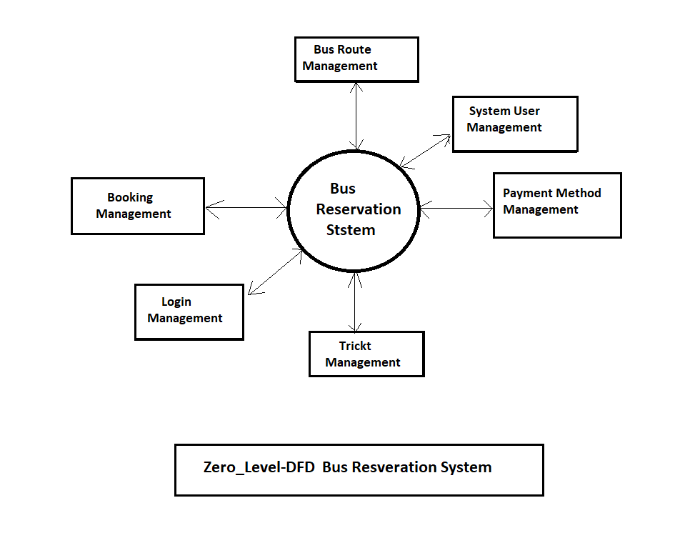
Fieger1.1: Data Flow Diagram Zero Level.

Data Dictionary Model (DMD):

Table Name: Login
Primary Key: user Secondary Key: Admin
Description: the information to login this site if you get the more information about but reservation system.
No | Field Name | Data type | Constraint | Description
1 | User _id | int | Primary key | To store the user id
2 | Username | Char | null | To store Username
3 | Password | Char, number | null | To store password

Table Name: Registration
Primary Key: User
Description: information about registration of user
No | Field Name | Data type | Constraint | Description
1 | Registration _id | int | Primary key | To store Registration id
2 | First Name | char | Null | To store First name
3 | Last Name | Char | Null | To store Last name
4 | Email id | Char, number | Null | Store Email id
5 | City | Char | Null | Store user city
6 | Contact_no | Number | Null | Store user contact number
7 | Address | Char | Null | Address

Table Name: Booking Seat
Primary Key: user
Description: information about the booking seat and detail
No | Field Name | Data type | Constraint | Description
1 | Book id | Int | Primary key | Store book id
2 | Registration id | Int |  | Reference to Registration
3 | F_name | Char | Null | Store First name
4 | L_name | Char | Null | Store last name
5 | Email id | Char, Number | Null | Store email id
6 | Contact_no | Number | Null | Store contact number
7 | Address | Char | Null | Store address
8 | City | Char | Null | Store city name
9 | Seat _no | Char | Null | Store bus seat number
10 | Date, Day | Char, number | Null | Store travelling date detail

Table Name: Bus Management
Primary Key: Admin
Description: information about Bus Ticket price and rate
No | Field Name | Data type | Constraint | Description
1 | Bus id | int | Primary key | Store bus id
2 | Bus Number | Char | NULL | Store bus number
3 | Bust type | Char | Null | Store bus type
4 | Total Seat | Int | Null | Store total seat available

_______________________________________________________________________________________

